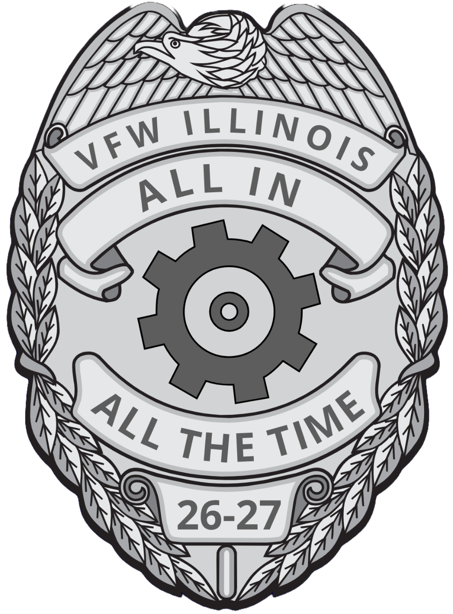

1. System Overview
The Post Dashboard and District Dashboard are fully updated to reflect all current All-State Requirements. Data from these individual dashboards automatically feeds into the National Programs Dashboard.

2. Reporting Timeline & Methods
- Program Year: Operates annually from July 1 through June 30.
- Real-Time Reporting: Events must be reported 365 days a year as they occur. Do not hold entries to report weekly, monthly, or quarterly (with the exception of Static Displays, as noted in the restrictions).
- Individual Entries: Record each activity as a separate event. Do not combine multiple events into a single, merged entry.
- Platform: All activities must be submitted online through the VFW Department of Illinois website at vfwil.org.
- Approval Process: Once a Post or District submits a report, State HQ must approve it before credit is officially applied to the dashboard.

3. Allowed Reporting Categories
Posts and Districts can ONLY submit activity reports for the following five categories:
- Community Service
- Veterans Assistance
- Youth Activities
- Legislative
- Illinois Specific
📌 State HQ Responsibilities: All other dashboard entries—including program nominations, National Home or Veterans Home donations (upon receipt of proof), meeting attendance, audits, bonds, inspections, and membership—are managed and input exclusively by State HQ.

4. Specific Guidelines
District Reporting
- Districts must use the specific "Post Number" that corresponds to their District.
- All District Post numbers are 20000 or greater, where the final digits match the District number.
- Example: District 3 uses Post number 20003. (Illinois includes Districts 3 through 19).
Auxiliary Reporting
- Posts are highly encouraged (though not mandated) to report their Auxiliary community service events.
- Auxiliary entries must utilize the exact same fields and detailed descriptions as standard Post entries.
- ⚠️ Critical Rule: Simply writing "Auxiliary Activity" in the description is not approvable.
Data Entry Restrictions
- Be Concise: Keep descriptions brief. Do not include detailed information on meeting motions or lists of specific members involved.
- Exceptions: You must identify the primary and alternate delegates when reporting on a County Veterans Assistance Commission (VAC).
- Reference Material: For detailed guidelines on individual programs, consult the 2026-2027 Commander's Leadership Manual.

5. Credit Rules & Total Impact Calculations
What Qualifies for Credit?
- Volunteer Execution: Credit is granted only for the actual execution of volunteer events.
- Administrative/Planning Time: Standalone planning or administrative time does not receive separate credit. However, this time, along with associated members and mileage, can be rolled into the final event entry.
- Formal Planning Exception: A formally called meeting with external community organizations to plan a major event (e.g., an Independence Day Celebration) is eligible for credit. The other participating organizations must be explicitly listed in the report.
Financial Standard Rates
- Value of a Volunteer Hour: $34.79 per member, per hour.
- Value of a Mile: $0.14 per mile (per current IRS rates).
Total Impact Formula
Community Service entries are considered incomplete without a Total Impact calculation. To determine the complete annual community footprint of your Post, use the following formula for every event:

$ + Hours + Mileage = Total Impact

The Program Reporting Form, Post Dashboard, and the District Dashboard are found in the Members Only Section of the vfwil.org web page.
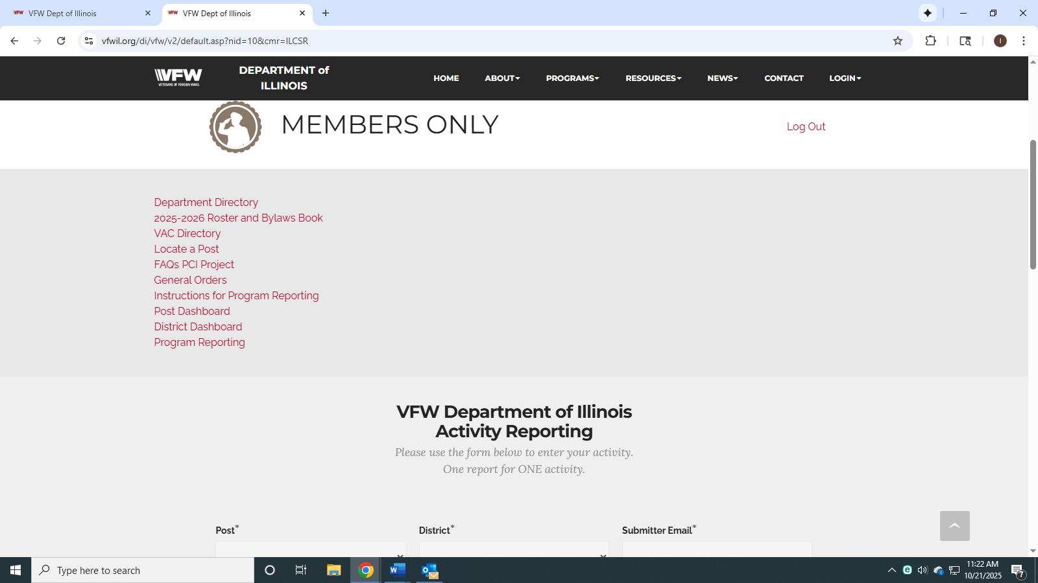
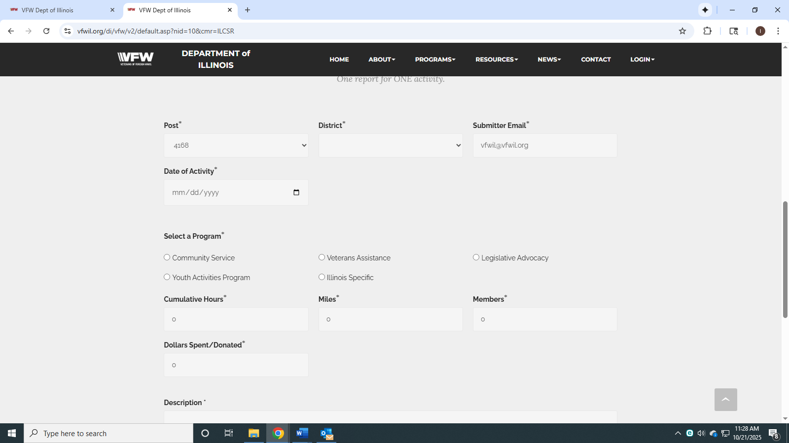

Illinois VFW Program Reporting & Dashboard Guide
This guide explains what activities qualify for program reporting, how to properly submit reports, and what actions are required to turn dashboard categories green for both Posts and Districts.
GENERAL REPORTING RULES
What Is a Program Report?
A Program Report documents activities performed by a Post or District that support veterans, youth, community service, legislative advocacy, Americanism, safety, or other VFW programs.

Reports should include:
- Date of activity
- Description of activity
- Number of volunteers
- Volunteer hours
- Dollars spent (if applicable)
- Dollars donated (if applicable)
- Number of participants served

Important Reporting Restrictions

Volunteer Activities Only
Credit is given only for volunteer activities.
No credit may be claimed for activities performed as part of paid employment.
Events Must Already Have Occurred
Reports may only be submitted after an event has taken place.
Planning meetings and preparation time may only be included with the complete event report.

Member Activities
Individual member activities only receive credit when the member is representing the Post.
Static Displays
Examples:
- POW/MIA Table
- Flags displayed at the Post
- Permanent patriotic displays

Limit reporting to:
- One hour per day per display
- Report monthly, not daily
Replacement costs may be reported as dollars spent.
COMMUNITY SERVICE
Community Activities
Programs initiated, organized, sponsored, or conducted by the Post.
Examples:
- Community cleanups
- Job fairs
- Clothing drives
- Food drives
- Veteran appreciation events

Dashboard Credit
Any report submitted under:
- Community Activities
- Disaster Relief
- Participation or Sponsorship of Community Activities

Disaster Relief
Activities supporting disaster victims.
Examples:
- Donations
- Volunteer support
- Supply drives

Participation or Sponsorship of Community Activity
Activities organized by another organization where the Post participates.
Examples:
- Volunteer labor
- Donations
- Hall rental support
- Sponsorships

Good Community Service Examples
- Voter registration campaigns
- Food bank support
- Job fairs
- Community cleanup projects
- Clothing drives
- Nursing home visits
- VA Home visits
- Care packages
- Donations to civic organizations
- Flag retirement programs

Non-Qualifying Community Service
Do not report:
- Regular Post dinners
- Member volunteering unrelated to Post representation
- Loaning Post facilities to Auxiliary, Cooties or VFW Riders

SAFETY PROGRAM
Qualifying Activities
- Safety education
- Community safety events
- Fire prevention programs
- Public safety awareness

Dashboard Credit
Any report submitted under:
- Safety Program Activities
- Public Servant Recognition turns the Safety section green.

Public Servant Recognition
- Police Officers
- Firefighters
- EMTs
- Dispatchers
- Other First Responders

AMERICANISM
Qualifying Activities
Flag Etiquette
- Flag education classes
- Flag retirement ceremonies

Honor Guard
- Veteran funerals
- Memorial services

Other Americanism Activities
- Presenting flags
- Replacing worn flags
- Encouraging voter participation
- Patriotic observances

Examples:
- Memorial Day
- Flag Day
- Independence Day
- Pearl Harbor Day
- Patriot Day
- POW/MIA Recognition Day

Dashboard Credit
Reports submitted under:
- Flag Etiquette
- Honor Guard turn the Americanism section green.

VETERANS ASSISTANCE
Qualifying Programs

Adopt-A-Unit
- Support active-duty military units.
Claims and Benefits Assistance
- Helping veterans access accredited service officers and benefits resources.
Homeless Veterans’ Assistance
- Providing support to homeless veterans or veterans in need.
Stand Down Participation
- Participation in veteran stand-down events.
Sports Clips Scholarship
- Scholarship program support.
VFW Mental Wellness
- Mental wellness activities and outreach.
Dashboard Credit
Any report in these categories turns Veterans Assistance green.
VA HOSPITAL and VETERANS HOME SUPPORT
Examples:
- Volunteering at VA facilities
- Transportation to appointments
- Meals or pantry support
- Support of State Veterans Homes
- National Home support activities

BUDDY POPPY
Conduct Buddy Poppy drives.
Important
All money collected through Buddy Poppy distributions must be deposited into the Relief Fund.
YOUTH ACTIVITIES
Qualifying Programs
- JROTC
- US Naval Sea Cadets
- Civil Air Patrol
- Student Scholarships
- Youth Program Donations

SCOUTING
Qualifying Programs
- Cub Scouts
- Scouts BSA
- Venturing
- Other recognized Scouting programs

LEGISLATIVE ADVOCACY
Qualifying Activities
- Witness slips
- State legislative meetings
- Federal legislative meetings
- National Action Alerts
- Legislative Conference attendance
- County Veterans Assistance Commission participation

ILLINOIS-SPECIFIC PROGRAMS
Blood Drive Program
To receive dashboard credit:
- The Post must host the blood drive.
- Enter the number of blood pints collected in the report description.

Recruiting Events
To receive dashboard credit:
- The Post must submit one recruiting event report.
Veteran Suicide Prevention
To receive dashboard credit:
- Host awareness events
- Partner with an approved suicide prevention or veteran mental health organization
- Submit documentation of participation, including photographs, event descriptions, and impact summaries.
POST DASHBOARD REQUIREMENTS
Contest Entries
Must submit:
- Voice of Democracy entry
- Patriot's Pen entry
- Teacher of the Year, Public Servant or Life Saving Award.

DONATION REQUIREMENT
Program | Minimum Donation
- Homeless Veterans | $50
- National Home | $50
- MAP/Unmet Needs | $50
- Commander's Special Project | $50
- Service Office Support | $75

BUDDY POPPY ORDERING
Must order:
- Five poppies per member
OR
- Minimum 500 poppies
ATTENDANCE REQUIREMENTS
A Post representative must attend:
- One Commander's Call
- District Meeting #1
- District Meeting #2
- District Meeting #3
- District Meeting #4

ADMINISTRATIVE REQUIREMENTS
Must complete:
- June Audit
- September Audit
- December Audit
- March Audit

Must be:
- Bonded
- Inspection passed

Membership must reach:
- 100% plus one member
- 80% retention of post annual membership

DISTRICT DASHBOARD REQUIREMENTS
Districts must:
- Advance Voice of Democracy to State
- Advance Patriot's Pen to State
- Submit Teacher of the Year nomination
- Submit Public Servant nomination
- Hold a School of Instruction
- Submit District Roll Calls
- Complete quarterly audits
- 80% of posts must attend a Commander’s Town Hall
- 100% of posts inspection approval
- Reach 100% plus one member
- Retain 80% of annual membership
- Host or participate in two membership recruiting events.
- Optional District donations qualify for green status when donation thresholds are met.

Examples of Proper reports

